Resolving Session Conflicts

Session conflicts occur when you attempt to maintain two or more TX-UNPS sessions in the same TX-UNPS environment from the same desktop/laptop computer. An example would include if a user attempts to login or operate within TX-UNPS in more than one tab or window or if user does not log out of TX-UNPS properly.

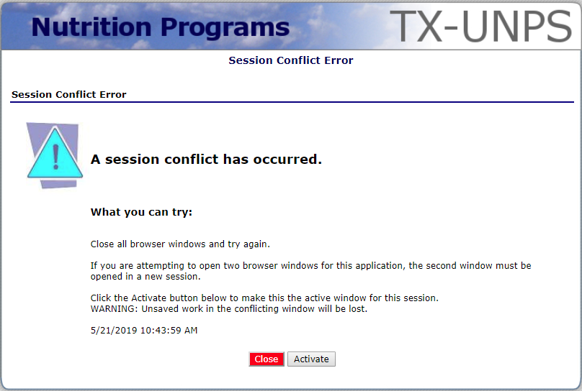

If you receive the above Session Conflict Error message, the system will want you to close the original, or first session, and activate the second session.
- If you have unsaved data on the original session, and you select the “Activate” button, the data will be lost.
- If you click the “Close” button, the second session will be closed and your will be returned to the original session.

If you continue to get the session conflict error, delete your temporary internet files and restart your computer.

To avoid this problem in the future, ensure you always click “Log Out” when exiting TX-UNPS. If you exit by clicking the “X” on your browser and try to open a new session, you will receive the Session Conflict Error screen.

